John Michael Go
Career Entry Level Java Programming
Date: Jan. 22, 2013

DAY 8

Program Name: Array8

Objective: Program that sorts an integer array in descending order.

Algorithm:

1. Program sorts an integer array in descending order.

Flowchart:

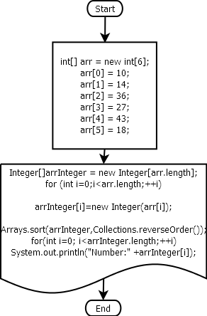

Pseudocode:

import java.util.Arrays;
import java.util.Collections;

public class Array8 {

public static void main(String[] args) {

int[] arr = new int[6];

arr[0] = 10;
arr[1] = 14;
arr[2] = 36;
arr[3] = 27;
arr[4] = 43;
arr[5] = 18;

Integer[]arrInteger = new Integer[arr.length];
for (int i=0;i<arr.length;++i)

arrInteger[i]=new Integer(arr[i]);

Arrays.sort(arrInteger,Collections.reverseOrder());
for(int i=0; i<arrInteger.length;++i)
System.out.println("Number:" +arrInteger[i]);
}

}

Screenshots:

